**Experiment 1**

**Aim:** To solve various arithmetic problems on debug.

**Prerequisites:** Windows 7 or Virtual machine in which Windows 7-32 bit version.(Only when the system is not windows 7 32 bit.)

**Theory:**

The line-oriented debugger is an external command in operating systems such as DOS, OS/2 and Windows (only in 16-bit/32-bit versions). DEBUG can act as an assembler, disassembler, or hex dump program allowing users to interactively examine memory contents (in assembly language). The use of debug command is used to look at portions of your computer and write assembly code to perform certain tasks like arithmetic operations on your computer. We are able to add, subtract, multiply and divide by just writing the code in 3-4 lines. When we want to start writing a program we should insert -a. Then start the code by assigning the values to ax and bx, then we need to mention the operation and finally end with int 21h. While displaying, we just need to input the command  called -t. The changes are seen whenever the command -t is runned. We need to enter the -t command till it completes the execution of each line.

**Output:**

1. **Addition of two 8-bit numbers.**

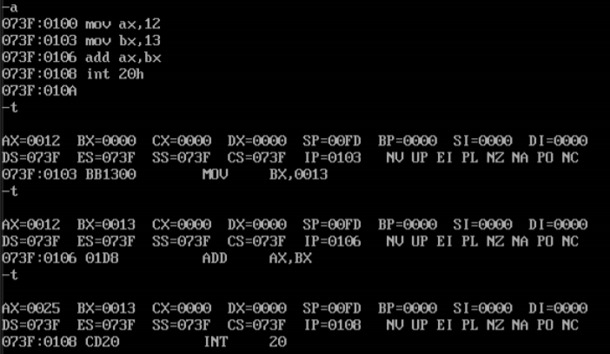

1. **Subtraction of two 8 bits numbers.**

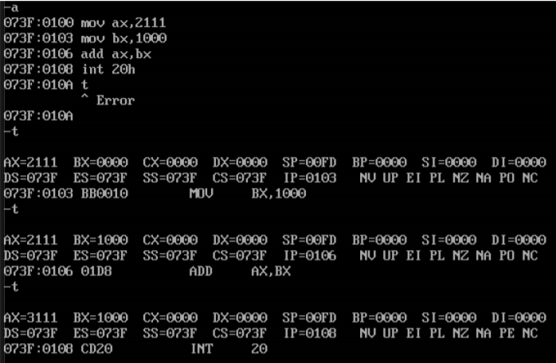

1. **Addition of two 16-bit numbers.**

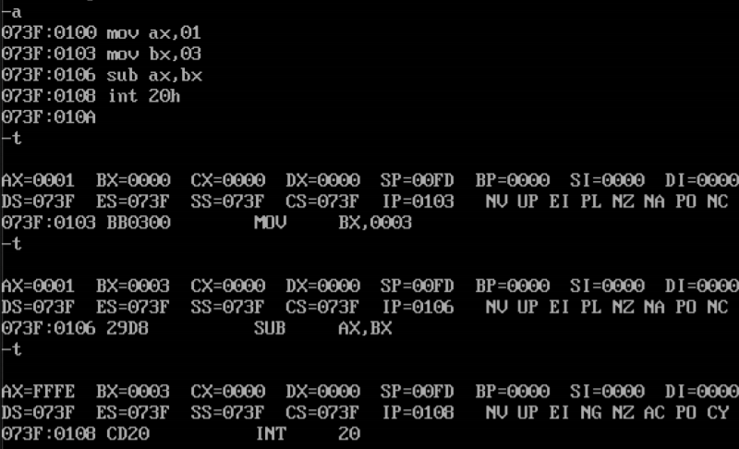

1. **Subtraction of two 16-bit numbers.**

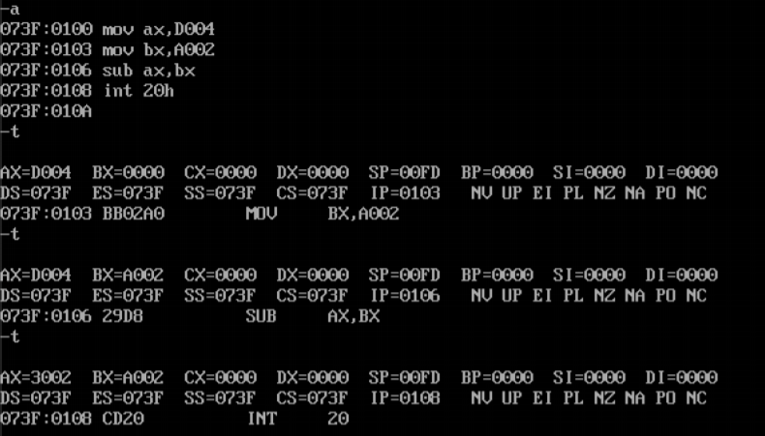

1. **Multiplication of two 8-bit numbers.**

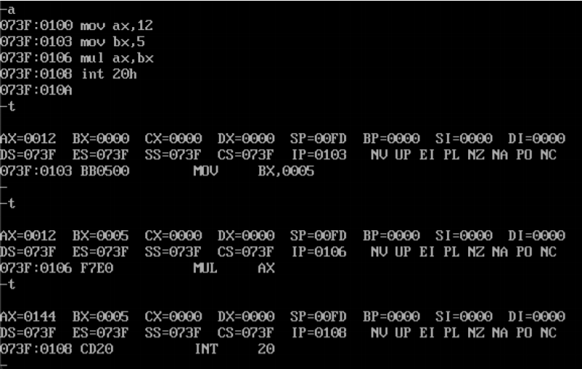

1. **Multiplication of one 16-bit number with one 8-bit number.**

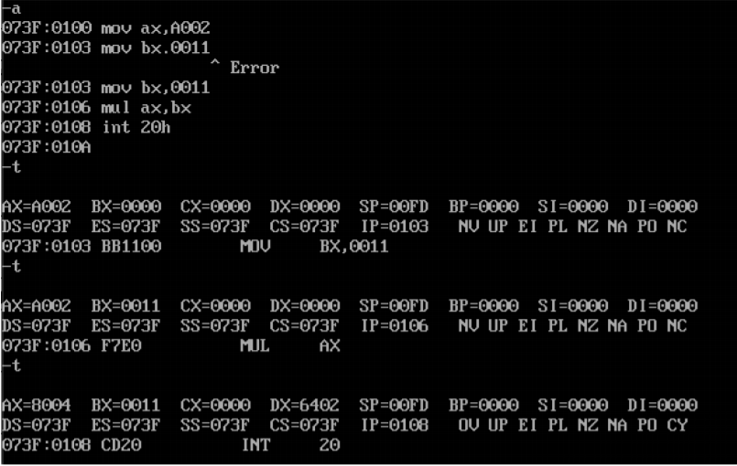

1. **Division of one 16-bit number with one 8-bit number.**

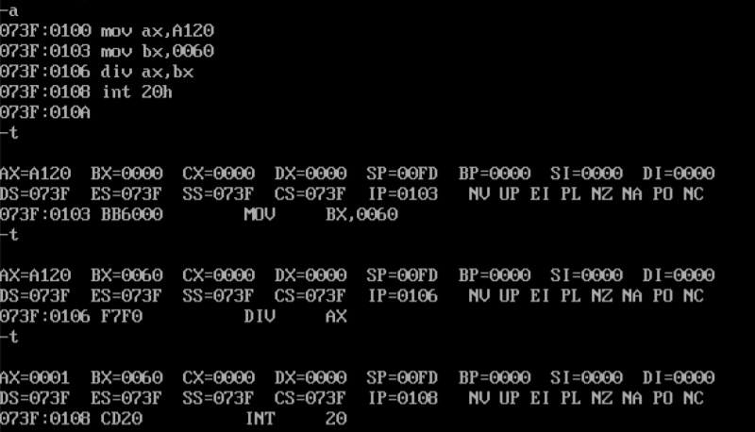

**Conclusion:**

Debug helps us to write assembly programs in an ordered manner. We are able to implement arithmetic problems using debug. We just need to learn some commands that are needed to implement programs in debug. So with debug we are able to learn to write and run assembly programs easily.